**HOW TO USE**

**(Requirements and Execution)**

**Report**:

Daily Closing

**Requirements:**

* Create the folders on the desktop:

C:\Users\59659\Desktop\MI Reports\Daily closing\2023\Aug\080123

**59659 Corresponds to the user of the PC where the program is executed.

**080123 The date must be changed to the execution day, format MMDDYY.

* 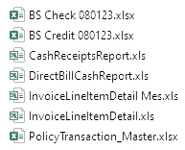The last folder should contain the indicated files:

**Execution**:

* Click on the program Daily Closing.exe



* A black screen will appear requesting the date of the file to be created (This must be in the format MMDDYY) and press ENTER.

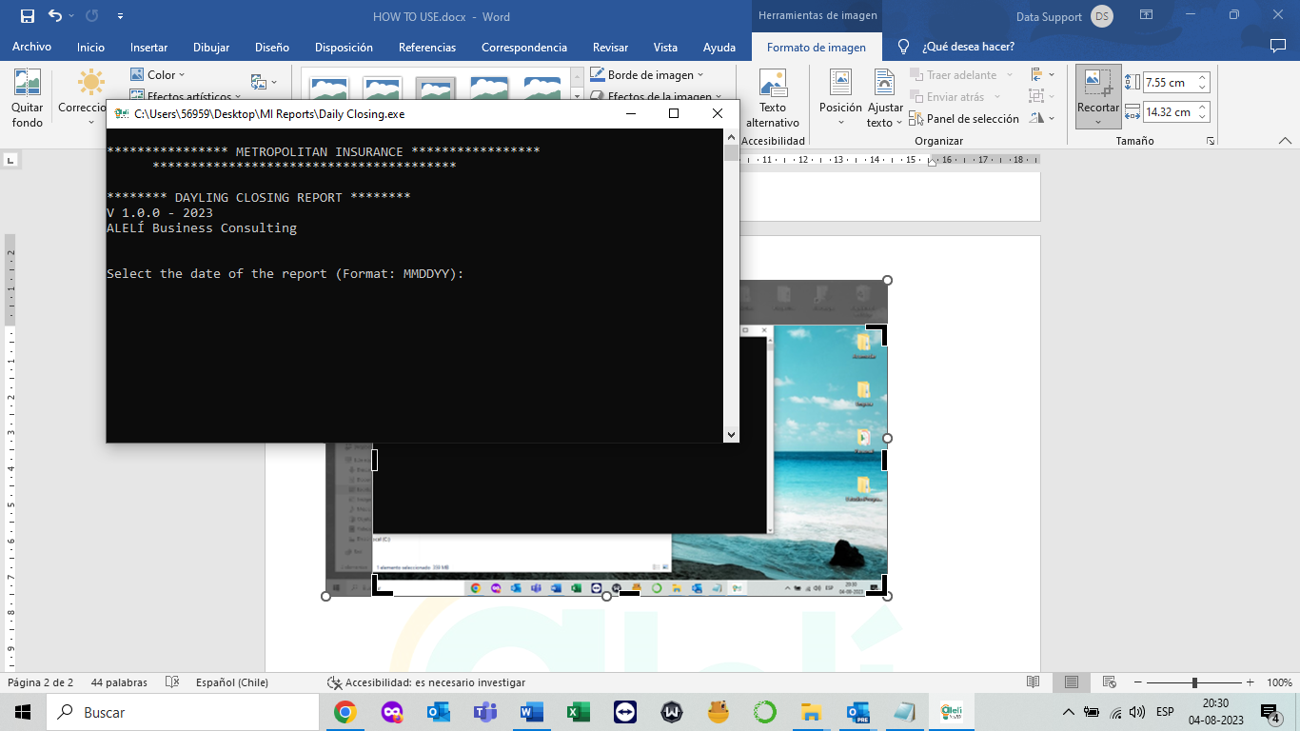

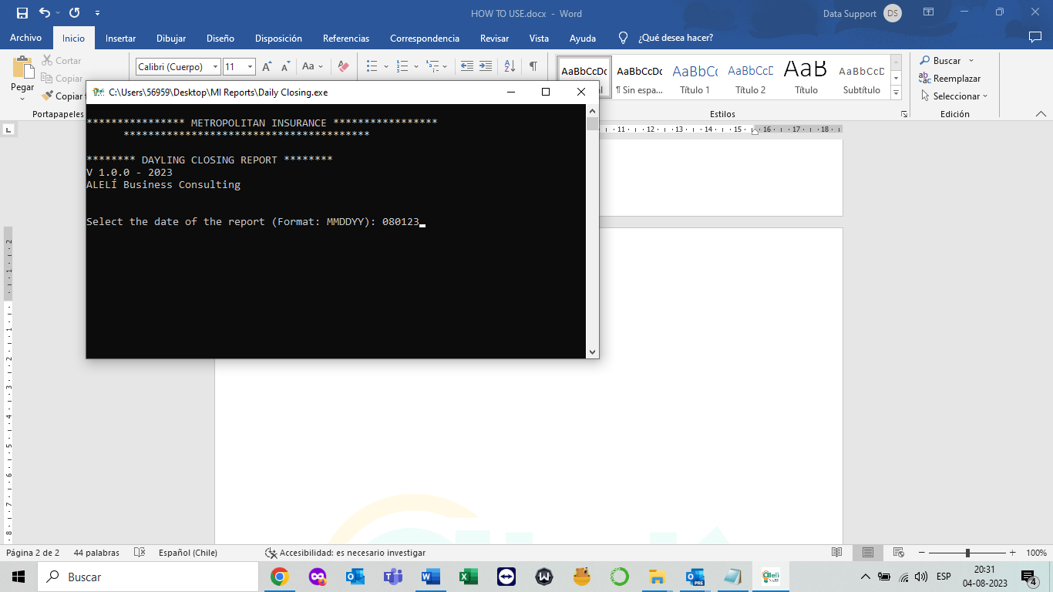

* When finished, the window will close automatically and the generated file will be found in the path next to the requirement files.

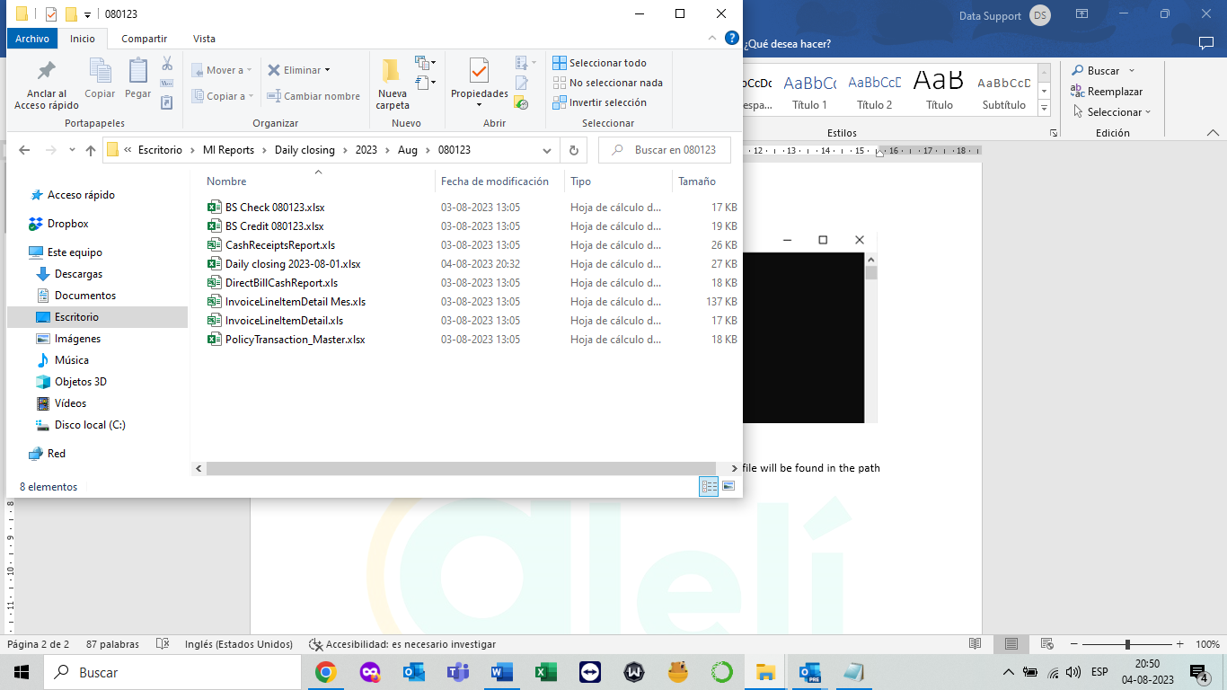

Any inconvenience contact the email datasupport@insurencemetropolitan.com or cmr@insurencemetropolitan.com.